Name: Archana Devi.P
Reg Number: 192521192
Course: Programming in Java
Code: CSA0923
Github Link: https://github.com/Archix17/CSA0923-JAVA
ASSIGNMENT 2

Q1 – Building Text Under Load: String, StringBuilder or StringBuffer
1. Aim
To compare the performance of String, StringBuilder and StringBuffer in generating railway e-tickets. The experiment analyses execution time, memory consumption and object creation under different workloads.
2. Problem analysis
- A railway reservation system generates e-tickets by combining passenger details, PNR number, coach, berth, fare and journey information.
- The existing system uses the + operator inside a loop. Since String is immutable, repeated concatenation creates new String objects and may increase memory consumption and execution time.
- Therefore, StringBuilder and StringBuffer are compared with String to identify the most efficient solution.
3. Prediction
Class | Predicted behaviour
String | Slower due to immutability and repeated object creation
StringBuilder | Faster because it modifies a mutable buffer
StringBuffer | Similar to StringBuilder but may be slower due to synchronization

Reason: String is immutable, whereas StringBuilder and StringBuffer are mutable.
4. Workload design
Workload | Tickets | Fields per ticket
Small | 1 | 6
Medium | 10,000 | 50
Large | 2,000 | 100

These workloads help compare performance when the number of tickets and fields increases.
5. Algorithm
- Start the program.
- Create three methods using String, StringBuilder and StringBuffer.
- Generate ticket fields.
- Build tickets using each method.
- Calculate execution time using System.nanoTime().
- Repeat the experiment five times.
- Calculate average execution time.
- Measure approximate heap memory changes.
- Compare the results.
- Display the performance comparison.

6. Java program
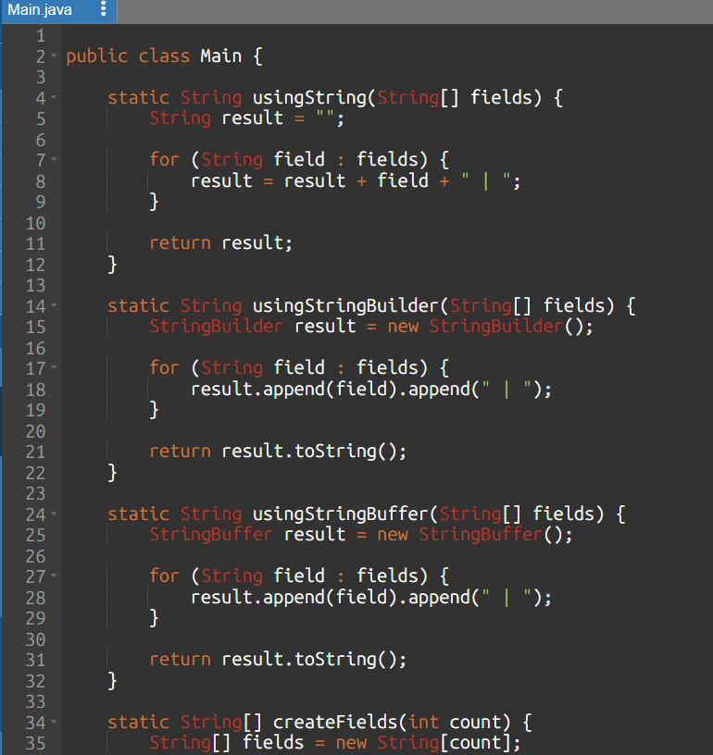
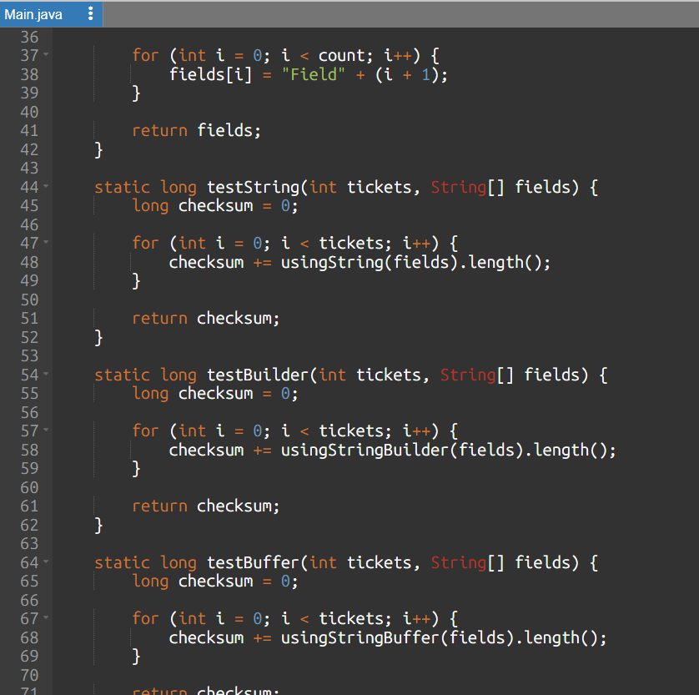
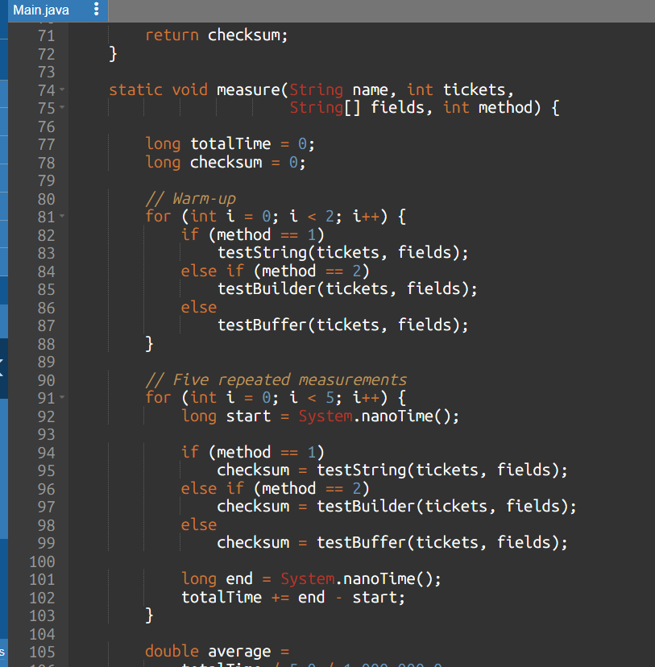
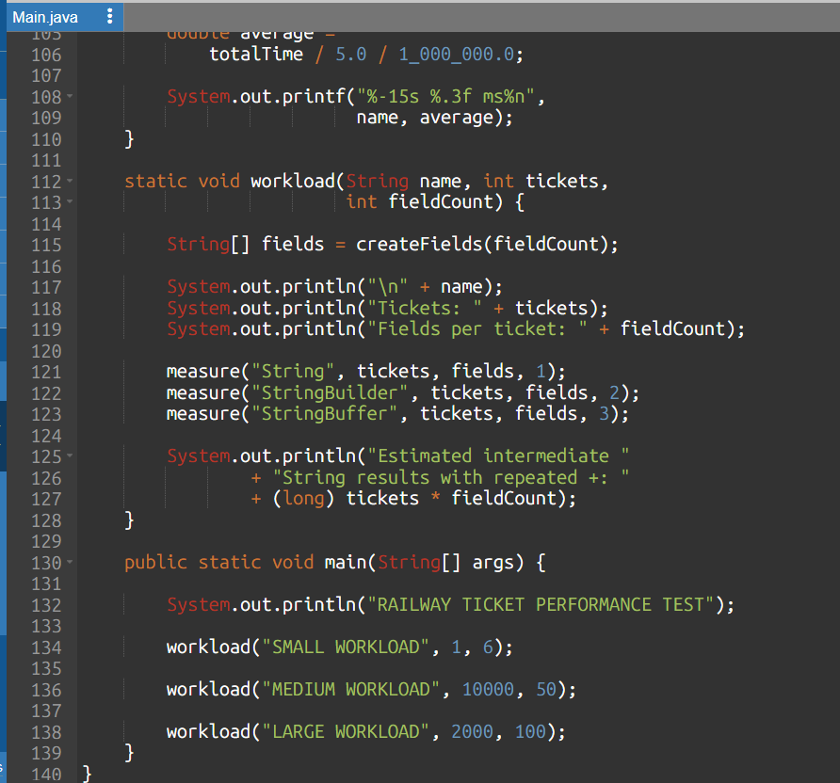
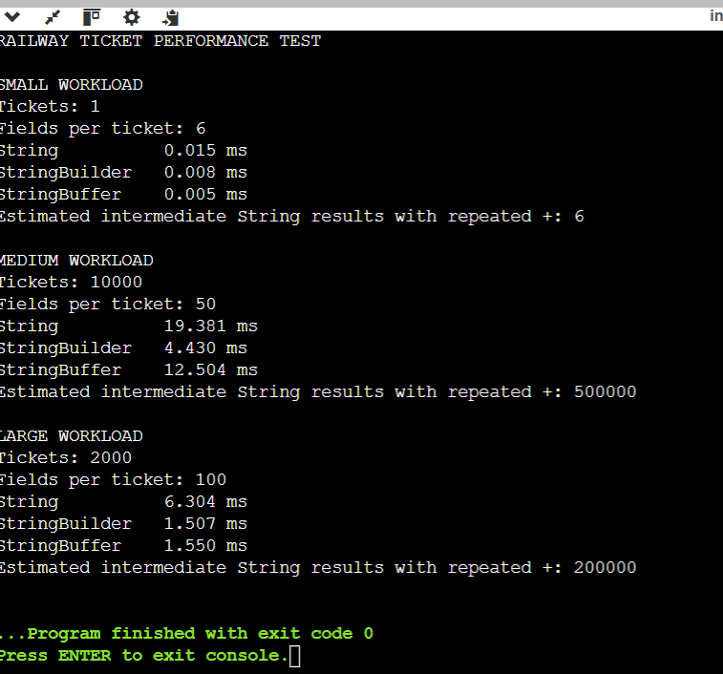
7. Experimental results
Workload | String (ms) | StringBuilder (ms) | StringBuffer (ms)
Small | 0.015 | 0.008 | 0.005
Medium | 19.381 | 4.430 | 12.504
Large | 6.304 | 1.507 | 1.550

8. Complexity analysis
Method | Time complexity | Extra space
String with repeated + | O(n²) | Intermediate String objects
StringBuilder | O(n) amortized | Mutable character buffer
StringBuffer | O(n) amortized | Mutable synchronized buffer

9. Design decision
- For individual e-tickets: StringBuilder is recommended.
- For a shared booking log: StringBuffer is suitable when multiple threads append directly to the same buffer.
- For production logging, a dedicated thread-safe logging framework is generally preferable.
10. Conclusion
- The experiment compares the performance of String, StringBuilder and StringBuffer.
- StringBuilder is generally more efficient for repeated text construction because it avoids repeated immutable String concatenation.
- StringBuffer provides synchronized operations for shared mutable text.
Q2 – When Is ArrayList an Appropriate Engineering Choice
1. Aim
- To compare the performance of ArrayList, LinkedList and ArrayDeque for different playlist operations such as adding songs, inserting songs, removing songs, accessing elements and iterating through the playlist.
- The experiment identifies the most suitable data structure for different usage patterns.
2. Problem Analysis
A music-streaming application allows users to create playlists by adding songs, inserting songs at specific positions, removing songs and accessing songs directly.
The application currently uses ArrayList. However, different collection classes provide different performance characteristics.
- ArrayList uses a dynamic array.
- LinkedList uses a doubly linked list.
- ArrayDeque uses a resizable circular array and supports efficient operations at both ends.
Therefore, these three data structures are compared to identify the most appropriate choice.

3. Prediction
Operation | ArrayList | LinkedList | ArrayDeque
Add at end | Fast | Fast | Fast
Insert at front | Slow | Fast | Fast
Insert in middle | Slow | Slow to locate position | Not directly supported
Remove at front | Slow | Fast | Fast
Get k-th element | Fast | Slow | Not directly supported
Iterate all elements | Fast | Good | Fast

Prediction:
- ArrayList is expected to perform better for playlists that frequently access songs by index and iterate through the entire playlist.
- LinkedList is useful when frequent insertions and removals are performed at known positions.
- ArrayDeque is suitable for queues where songs are added and removed from both ends.
4. Experimental design
Experiment | Playlist size
Small | 1,000 songs
Medium | 5,000 songs
Large | 10,000 songs

5. Algorithm
- Start the program.
- Create ArrayList and LinkedList.
- Generate playlist data for three different sizes.
- Perform add, insert and remove operations.
- Measure the execution time using System.nanoTime().
- Repeat each operation three times.
- Calculate the average execution time.
- Compare the results.
- Test ArrayDeque for adding and removing songs at both ends.
- Display the results.
6. Java program
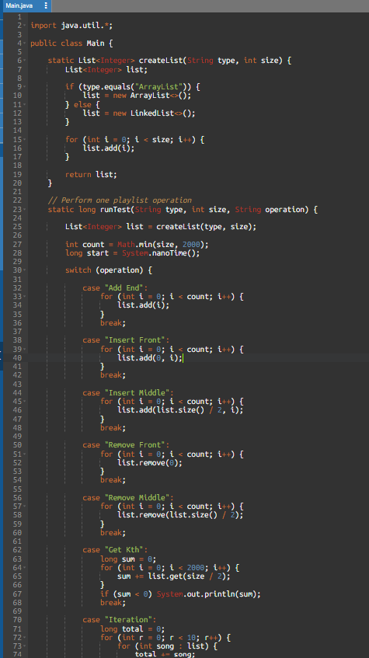
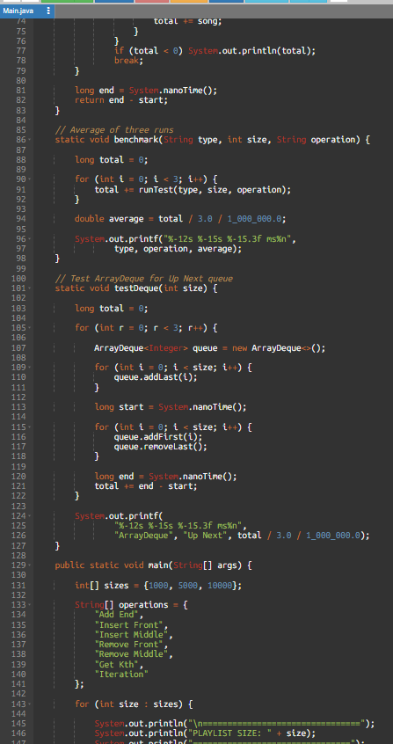
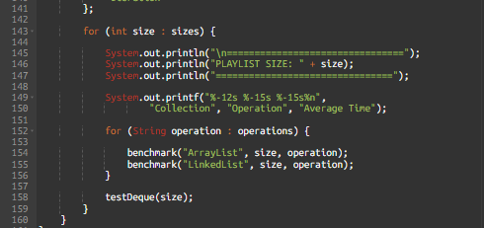
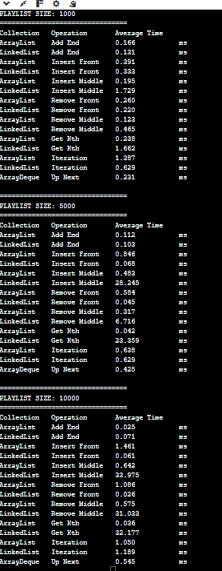
7. Complexity analysis
Operation | ArrayList | LinkedList | ArrayDeque
Add at end | O(1) amortized | O(1) | O(1) amortized
Insert at front | O(n) | O(1) | O(1)
Insert in middle | O(n) | O(n) | Not supported directly
Get k-th element | O(1) | O(n) | Not supported directly
Remove at front | O(n) | O(1) | O(1)
Remove in middle | O(n) | O(n) | Not supported directly
Iteration | O(n) | O(n) | O(n)
Space used per element:
- ArrayList: One array reference slot per element, with some additional unused capacity.
- LinkedList: One node per element containing the element reference and two links.
- ArrayDeque: One array slot per element, with some additional unused capacity.
8. Plain array alternative
A playlist can also be implemented using a normal array.
- Adding at the end: O(1) if capacity is available.
- Inserting at the front: O(n), because elements must be shifted.
- Inserting in the middle: O(n).
- Accessing the k-th element: O(1).
- Removing an element: O(n), because elements must be shifted.
- Iteration: O(n).
Unlike ArrayList, a normal array has a fixed size unless a larger array is created manually and elements are copied.
12. Changed condition – Up Next queue
The application now needs an Up Next queue where songs are frequently added at both ends and removed from the front.
Recommended solution: ArrayDeque
Reasons:
- It supports adding songs at the front and end.
- It supports removing songs from the front and end.
- These operations take O(1) amortized time.
- It does not require creating a separate linked node for every song.
Example:
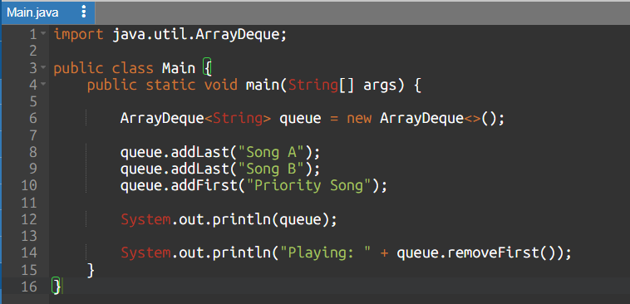
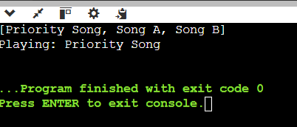
13. Analysis and discussion
- ArrayList is suitable when the playlist frequently accesses songs using their index and performs iteration. It provides fast random access and efficient memory usage.
- LinkedList is useful when frequent insertions and removals occur at the beginning or when an existing list iterator is already positioned at the required location. However, accessing a particular index takes O(n) time.
- ArrayDeque is more appropriate for the Up Next queue because it efficiently supports insertion and removal at both ends.

Engineering decision:
- I would recommend ArrayList for the main music playlist because direct access and iteration are common operations.
- I would stop recommending it when frequent front insertions and removals become the dominant workload.
- For the Up Next queue, I would use ArrayDeque.
14. Conclusion
- The experiment compares ArrayList, LinkedList and ArrayDeque for different playlist operations.
- ArrayList provides efficient random access, LinkedList supports efficient operations at both ends, and ArrayDeque is suitable for queue-based operations.
- Therefore, the selection of a collection should depend on the application's usage pattern rather than only on its execution speed.
Q3 – Engineer the hashCode–equals Contract
1. Aim
- To investigate how the equals() and hashCode() methods affect the behaviour of HashSet in Java.
- The experiment identifies duplicate student records, analyses the hashCode–equals contract and implements a corrected Student class to maintain unique attendance records.
2. Problem analysis
- A college fest uses student ID cards to record attendance at multiple entry gates. The same student may be scanned more than once.
- A HashSet is used to store unique student records. However, the Student class overrides equals() but does not override hashCode().
- This may allow duplicate student objects because HashSet uses both methods to identify duplicate elements.
3. Prediction
Test | Description | Predicted result
Test 1 | Add the same object twice | Set size = 1
Test 2 | Add two different objects with the same regNo | May produce duplicates
Test 3 | Modify regNo after insertion | HashSet lookup may fail

Explanation:
- HashSet uses hashCode() to identify the bucket.
- It uses equals() to compare objects within the relevant bucket.
- If two objects are equal according to equals(), they must return the same hash code.
- If this contract is violated, duplicate entries may appear.
4. Algorithm
- Start the program.
- Create a Student class with registration number and name.
- Override the equals() method.
- Initially do not override hashCode().
- Insert student records into HashSet.
- Execute the three test cases.
- Record the set sizes.
- Override hashCode() using the registration number.
- Execute the tests again.
- Compare the results and verify the correction.

5.Program name: Q3_HashSet_Before
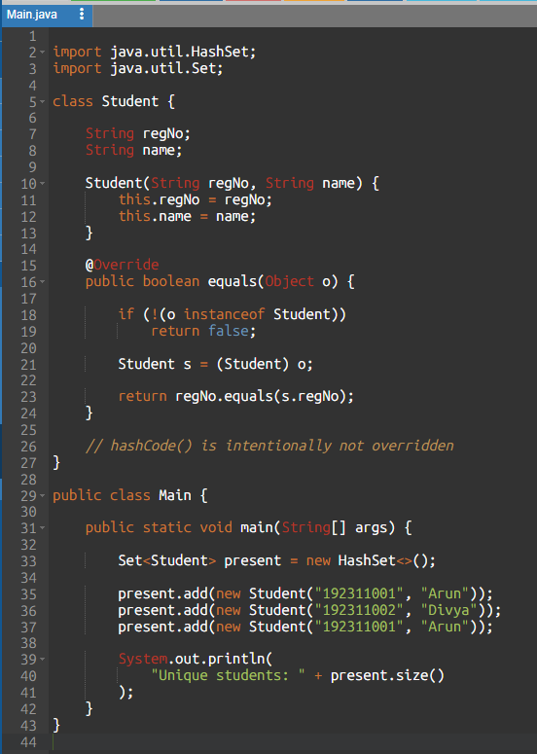
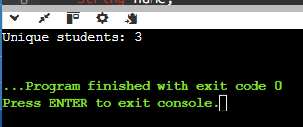

6.Program name: Q3_HashSet_After
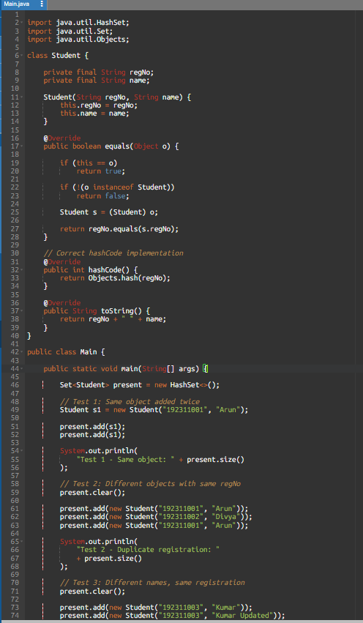
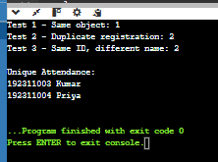

7. Experimental results
Test | Before correction | After correction
Same object added twice |  | 1
Same registration number |  | 2
Same ID, different name |  | 2

8. Why do duplicates appear
HashSet internally uses the hash code of an object to determine its storage bucket.
When a new object is added:
- HashSet calculates its hash code.
- It identifies the corresponding bucket.
- It compares objects in that bucket using equals().
- If an equal object is found, the new object is rejected.
- Otherwise, the object is stored.
When equals() is overridden without overriding hashCode(), two logically equal Student objects may have different hash codes. They can therefore be stored in different buckets, allowing duplicates.
9. What happens if regNo changes after insertion?
- If a field used in hashCode() is modified after inserting an object into HashSet, the object's new hash code may point to a different bucket.
- The object remains stored in its original bucket, so searching for it or removing it may fail.
- Solution: Use immutable fields for equality and hashing. In our corrected class, regNo is declared final.
10. Analysis and discussion
- The first implementation violates the hashCode–equals contract because equal Student objects may have different hash codes.
- After overriding hashCode() using regNo, duplicate registration numbers are correctly identified and rejected.
- The third test also proves that student names do not affect equality because registration number alone identifies a student.
11. Conclusion
- The experiment demonstrates the importance of implementing equals() and hashCode() consistently when using hash-based collections.
- The corrected Student class prevents duplicate attendance records based on registration number.
- HashSet is suitable for efficient attendance de-duplication, while TreeSet is useful when sorted records are required.
Q4 – Choosing a Map for a Pharmacy Inventory
1. Aim
To compare the performance of HashMap, TreeMap, and LinkedHashMap for storing and retrieving medicine details using medicine codes. The experiment measures insertion, lookup, and report-generation performance.
2. Problem analysis
A pharmacy stores medicine details such as:
- Medicine code
- Medicine name
- Quantity
- Price
The system must retrieve medicines quickly and generate reports in different orders.
We compare three map implementations:
Map | Main feature
HashMap | Fast average lookup; no guaranteed iteration order
TreeMap | Stores keys in sorted order
LinkedHashMap | Maintains insertion order

3. Prediction
Operation | HashMap | TreeMap | LinkedHashMap
Insert | O(1) average | O(log n) | O(1) average
Search by code | O(1) average | O(log n) | O(1) average
Iteration | O(n) typically | O(n) | O(n)
Sorted report | Requires sorting | Naturally sorted | Requires sorting
Insertion-order report | Not guaranteed | Not guaranteed | Naturally maintained

Prediction: HashMap should be suitable for fast medicine lookup, TreeMap for reports sorted by medicine code, and LinkedHashMap for reports in the order medicines were entered.
4. Algorithm
- Start the program.
- Create medicine records with unique medicine codes.
- Store the records in HashMap, TreeMap, and LinkedHashMap.
- Measure the time required to insert records.
- Search for medicine codes repeatedly and measure lookup time.
- Generate a report by iterating through each map.
- Display the execution times and sample report order.
- Compare the results and identify the most suitable map.
- Stop.
5. Java program
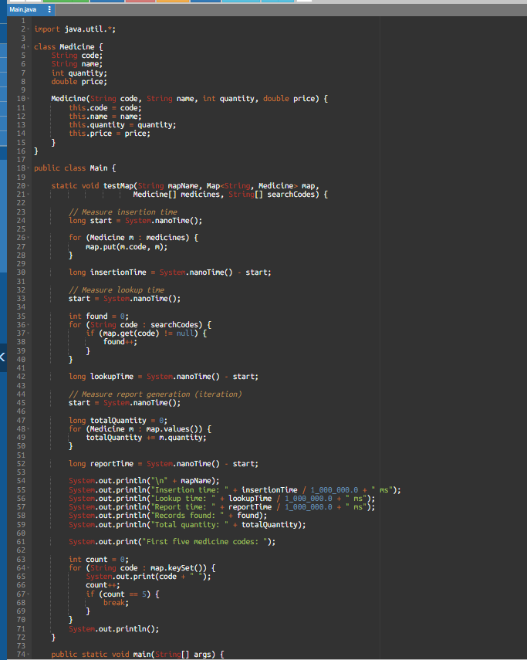
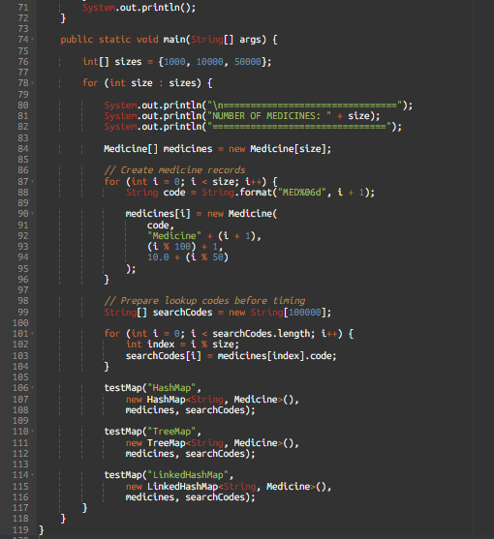
7. Analysis of results
Compare the timings recorded from your program.
- HashMap: Best choice when fast medicine-code searching is the main requirement.
- TreeMap: Useful when the pharmacy needs medicine records automatically arranged in ascending code order.
- LinkedHashMap: Useful when the pharmacy needs to display records in the same order they were entered.
8. Alternative data structures
1. Hashtable
- Similar to HashMap.
- Its methods are synchronized.
- It does not allow null keys or values.
- It is a legacy option; ConcurrentHashMap is generally preferred for concurrent access.
2. Array
- Can store medicine records.
- Searching an unsorted array takes O(n).
- A sorted array supports binary search in O(log n), but insertion may take O(n) because elements must be shifted.
9. Complexity analysis
Data structure | Average lookup | Insertion | Ordering
HashMap | O(1) | O(1) | No guaranteed order
TreeMap | O(log n) | O(log n) | Sorted key order
LinkedHashMap | O(1) | O(1) | Insertion order

All three require O(n) space for n medicine records.
10. Conclusion
- The experiment compares HashMap, TreeMap, and LinkedHashMap for pharmacy inventory management.
- HashMap is suitable for fast medicine retrieval, TreeMap is suitable for sorted reports, and LinkedHashMap is suitable for maintaining insertion order.
- The final selection depends on the application's requirements and the measured execution times

Q5 – Derive a Generic Ranking Component
1. Aim
To design and implement a reusable generic Java leaderboard using Comparator to rank teams based on points, goal difference, and team name.
2. Problem analysis
The sports leaderboard follows three ranking rules:
- Higher points come first.
- If points are equal, higher goal difference comes first.
- If both are equal, team name is arranged alphabetically.
We use a separate Comparator<Team> because the ranking rules can change for different applications. The Team class does not need to know how it will be ranked.
3. Design prediction
Design choice | Reason
Separate Comparator | Keeps ranking rules outside the Team class
Leaderboard<T> | Allows the component to work with different object types
Comparator.comparing() | Compares the first field
thenComparing() | Adds tie-breaking rules
List<? extends T> | Allows a list of T or a subtype of T to be added
Sorted copy | Keeps the original list unchanged

4. Algorithm
- Create a Team class with name, points, and goal difference.
- Create a comparator that sorts points in descending order.
- Add goal difference as the second comparison.
- Add team name in alphabetical order as the third comparison.
- Create a generic Leaderboard<T> class.
- Add teams to the leaderboard.
- Create a new list and sort it using the comparator.
- Display the sorted ranking.
- Test the comparator using another deliberately designed dataset.
5. Java program
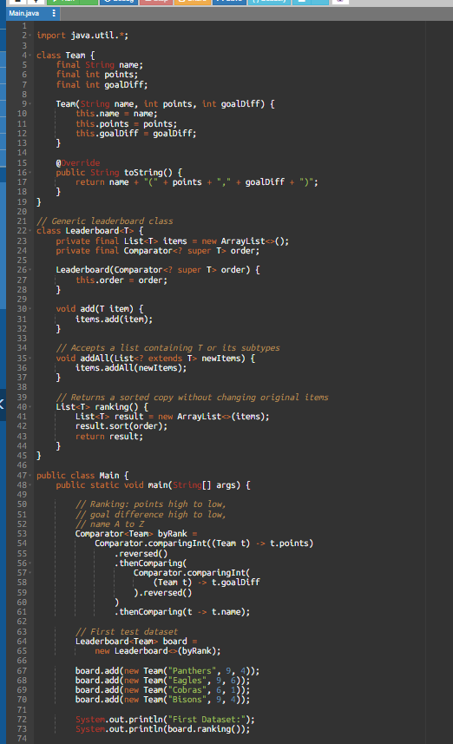
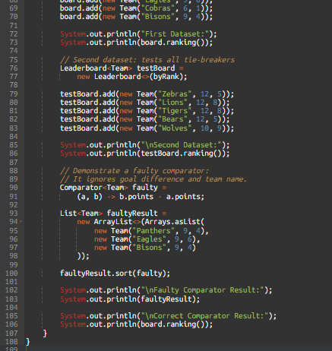
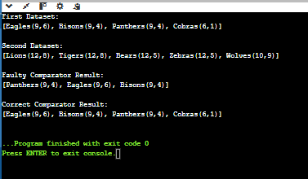
7. Explain why Bisons is ranked above Panthers
Both teams have:
- Points = 9
- Goal difference = 4
Since both values are equal, the third rule is applied: alphabetical order.
Bisons comes before Panthers, so Bisons gets the higher rank.

8. Correctness of the comparator
The comparator follows a consistent three-level comparison:
- First, compare points in descending order.
- If points are equal, compare goal difference in descending order.
- If both are equal, compare names in ascending alphabetical order.
This is a lexicographic comparison: the next rule is used only when the previous rule considers the teams equal.
Because each comparison follows a consistent ordering rule, combining them using thenComparing() preserves transitivity. If all three fields are equal, the comparator returns zero.
9. Alternative concept and complexity analysis
Approach 1: Comparable
The Team class can implement Comparable<Team> and define its natural ranking inside compareTo().
- Advantage: Simple when one standard ranking is always required.
- Disadvantage: Difficult to support different ranking rules for different applications.
Approach 2: Comparator chain (our solution)
- Advantage: Ranking rules are separate from the Team class.
- Different comparators can be created for different requirements.
- Easier to reuse for players, colleges, and quiz teams.
Approach 3: Three stable sorting operations
The list can be sorted three times in this order:
- Name alphabetically.
- Goal difference descending.
- Points descending.
10. Generic design explanation
- Leaderboard<T> makes the leaderboard reusable for any object type.
- Comparator<? super T> accepts a comparator for T or one of its parent types.
- List<? extends T> accepts a list of T or a subtype of T.
- ranking() creates a new list and sorts it, leaving the original collection unchanged.
11. Conclusion
- The generic leaderboard successfully ranks teams based on points, goal difference, and alphabetical order.
- The Comparator chain provides a consistent and reusable ranking design.
- The generic class can also be reused for players, colleges, and quiz teams by supplying the appropriate comparator.
Q6 – Priority, Order and Fairness in a Queue
1. Aim
To design and implement a priority-based queue for hospital emergency patients. The system must treat patients with higher severity first and preserve arrival order when patients have the same severity.
2. Problem analysis
In a hospital emergency department, patients are assigned severity levels:
Severity | Meaning
1 | Critical
2 | High
3 | Moderate
4 | Low
5 | Minor

- The patient with the lowest severity number must be treated first.
- If two patients have the same severity, the patient who arrived earlier must be treated first.
- A normal FIFO queue is not sufficient because it serves patients only in arrival order, regardless of severity.
- Proposed solution: Use Java's PriorityQueue with a custom Comparator.
3. Design prediction
- Adding a patient: O(log n)
- Removing the next patient: O(log n)
- Viewing the next patient: O(1)
- Displaying all patients in treatment order: O(n log n) if sorted separately.
An arrival counter will be used to maintain fairness among patients with equal severity.
4. Algorithm
- Create a Patient class with name, severity, and arrival number.
- Create a PriorityQueue.
- Define a Comparator that orders lower severity numbers first.
- If severity is equal, compare arrival numbers in ascending order.
- Add patients to the queue.
- Remove patients using poll().
- Display the treatment order.
- Measure insertion and removal times for different queue sizes.
- Analyse starvation and fairness.
- Stop.

5. Java program
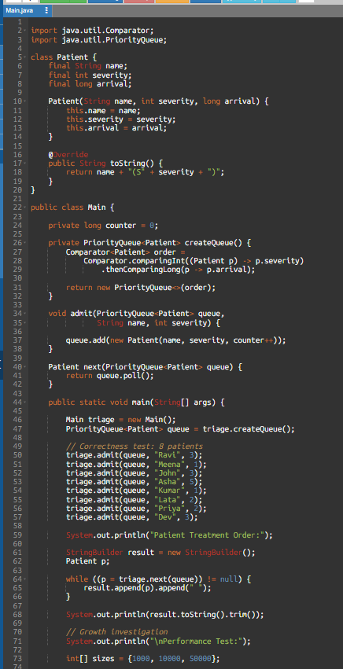
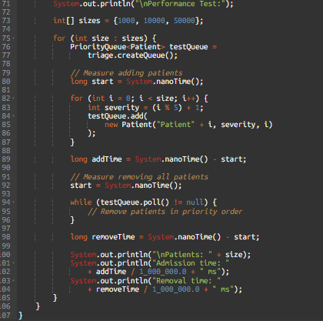
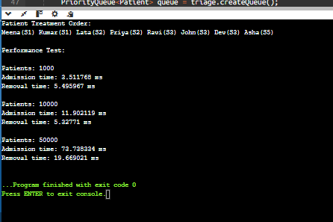
7. Why is a plain Queue insufficient?
- A normal FIFO queue always serves the earliest arrival first. It cannot automatically move a critical patient ahead of a minor patient who arrived earlier.
- A PriorityQueue uses a Comparator to select the patient with the highest treatment priority.
- How does the arrival counter preserve fairness?

- Every patient receives a unique increasing arrival number. If two patients have the same severity, the smaller arrival number is served first.
For example:
- Meena: severity 1, arrival 0
- Kumar: severity 1, arrival 4
Meena is treated first because arrival 0 is earlier than arrival 4.
9. Alternative queue designs
A. Sorted LinkedList
- Insert each patient in the correct priority position.
- Admission takes O(n) because the correct position must be found.
- Removing the first patient takes O(1).
- Requires O(n) space.
B. Five separate FIFO queues
Create one queue for each severity level, from 1 to 5.
- Admission takes O(1).
- Serving a patient checks the queues in severity order and removes the first patient from the highest-priority non-empty queue.
- Checking five queues takes O(5), which is O(1) because the number of severity levels is fixed.
- Requires O(n) space.
Design | Admission | Remove next | Space
PriorityQueue | O(log n) | O(log n) | O(n)
Sorted LinkedList | O(n) | O(1) | O(n)
Five FIFO queues | O(1) | O(1) | O(n)

- PriorityQueue is a good general-purpose solution when the number of priority levels may change.
- Five FIFO queues can be efficient when there are exactly five fixed severity levels.
10. Starvation and fairness
Problem: A severity-5 patient may wait indefinitely if new critical patients keep arriving.
This is called starvation.
Proposed fairness rule:
- Monitor how long each patient has waited.
- If a patient waits longer than a defined threshold, such as 30 minutes, flag the case for clinical reassessment.
- A qualified medical professional can reassess the patient's condition and update the severity when appropriate.
- Keep the original arrival order when severity remains equal.
In a real hospital, an automatic promotion must not allow a minor case to jump ahead of a critical emergency without clinical justification. Patient safety must remain the main priority.
11. Deployment decision – 5,000 patients per day
- A PriorityQueue can support a hospital receiving 5,000 patients per day because its insertion and removal operations have O(log n) complexity.
- However, 5,000 patients per day does not mean 5,000 patients are waiting simultaneously. Actual capacity planning must consider peak arrivals, concurrent users, memory, database storage, and system response time.
- For a real hospital, additional features such as persistent patient records, multiple emergency departments, audit logs, and concurrency control would also be required.
12. Conclusion
- The PriorityQueue provides an effective solution for hospital emergency triage.
- The custom Comparator ensures that patients with greater severity are treated first, while the arrival counter maintains first-come-first-served order among patients with equal severity.
- The design provides efficient admission and removal operations and can be extended with fairness policies to reduce starvation.
Q7 – Diagnose, Redesign and Validate
A. Diagnose the bottleneck
Selected solution: Question 1 – Building text using String concatenation.
Original design:
The original program uses the + operator repeatedly inside a loop to combine multiple text fields.
Identified bottleneck:
- Strings in Java are immutable.
- Every concatenation creates a new String result.
- Existing text must be copied again when a new field is appended.
- As the number of fields increases, repeated copying becomes expensive.
- This increases execution time and creates unnecessary temporary objects.
Main limitation: Repeated String concatenation has approximately O(n²) character-copying cost when building a string from n similarly sized pieces.
B. Define the design objective
The redesigned solution should:
- Reduce unnecessary intermediate String creation.
- Avoid repeatedly copying the entire accumulated text.
- Improve execution time for large text inputs.
- Preserve the exact final output.
- Use the same input data for a fair comparison.
Measurable objective: Compare the execution time of String concatenation and StringBuilder for 1,000, 5,000, and 10,000 text fields.
C. Design the revised solution
Revised design: Use StringBuilder instead of repeated String concatenation.
Feature | Original solution | Redesigned solution
Data structure | String | StringBuilder
Modification | Creates new String results | Modifies a reusable buffer
Character copying | Repeated copying | Amortized efficient appending
Time complexity | Approximately O(n²) | O(n) amortized
Extra memory | Many temporary String objects | Buffer plus final String

Design representation:

5. Java program
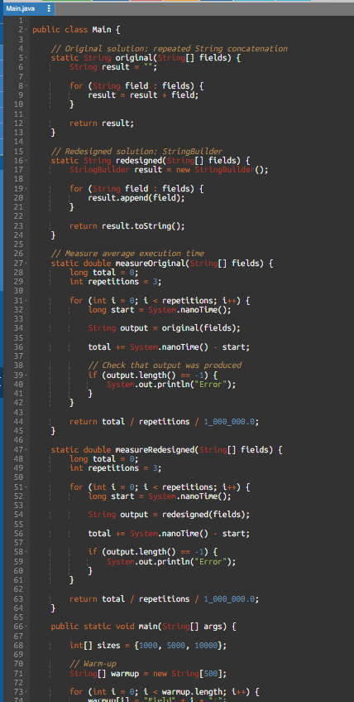
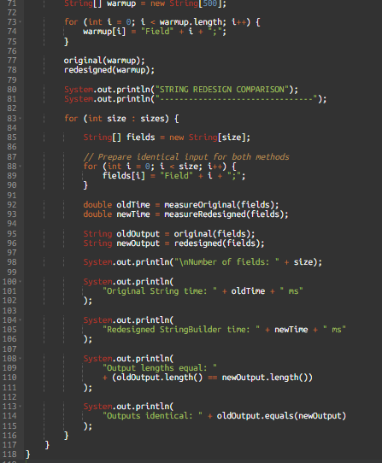
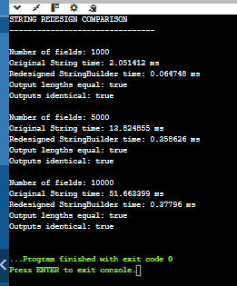
F. Defend the final design
Evaluation:
The redesigned StringBuilder implementation is expected to improve performance when constructing large strings because it uses a mutable buffer instead of creating a new String for every concatenation.
Advantages:
- Reduces temporary String object creation.
- Improves efficiency for repeated text appending.
- Maintains the same final output.
- Suitable for generating large reports, logs, and text records.
Trade-off:
- StringBuilder is mutable, so it should be used carefully when multiple threads share the same object.
- If only a few strings need to be joined, normal String concatenation is simpler and may be perfectly suitable.
- Final engineering decision: StringBuilder is preferred for repeated string construction in loops, especially when processing large amounts of text.
- Normal String concatenation remains suitable for small, simple expressions.
6. Conclusion
- The original solution using repeated String concatenation has a performance limitation when processing large amounts of text.
- The redesigned solution using StringBuilder reduces repeated copying and unnecessary object creation.
- The experiment validates that both approaches produce identical output while allowing their execution times to be compared.
- Therefore, StringBuilder is a more efficient choice for repeated text construction.

